



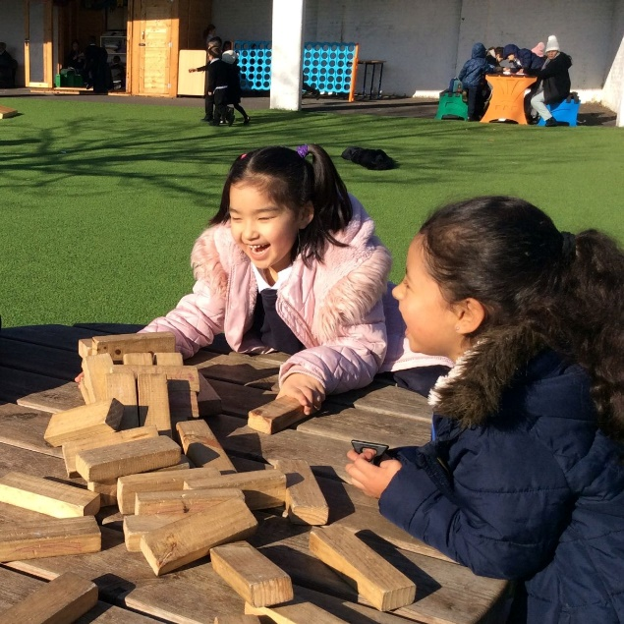

AFTER SCHOOL CLUB ACTIVITIES
Autumn Term 2025

Monday
3.15.- 4.15

Gymnastics | Tuesday  3.15-4.30
 | Sportacus will be delivering this club. They have designed their gymnastics curriculum to incorporate a variety of skills and apparatus so the children can turn their hands to different activities. All their skills are tailored to suit the abilities of the children from the beginners to children who are familiar with gymnastics. | 10 Spaces  Paid direct to Sportacus  Instructions to follow

Yoga | Thursday  3.30-4.30
Years 2-6 | Delivered by Trinity’s yoga teacher, at Yoga Club we explore movement, breath, and rest while using our imagination, creativity, and playfulness. Each session aims to empower each child and teach the principles of mindfulness, self-compassion, awareness, and self-regulation in a fun and accessible way. | Awaiting spaces;  Spaces assigned termly

Performing Club | Thursday  3.15-4.15
Years 3-6 | Combined choir and band club where KS2 pupils can either sing in the choir or play accompanying music - no singing skills needed but if you would like to play in the band, instrument skills required (should be able to read some music). This is a year-round club building on skills and performances each term such as our music showcases and Turning of the Year. There will be a waitlist for any overflow. | Assigned by teacher

Music Club | Tuesday 3.15 -4.15
Years 3 to 6 | Aimed for anyone in KS2 who currently learns an instrument and would like to come along for a lunchtime jamming session. Some instrumental skills needed. | Assigned by teacher

Tennis | Monday  3.05- 4.15
Years 3 to 6 | Ms Tayler is running a Tennis club at Manor House Gardens.  Any level of tennis knowledge if welcome – bringing own rackets is ideal. Club leaves early from Trinity to get (almost) a full hour of instruction in.  Club runs half term only due to light. | 8 spaces

Book Club | Tuesday Lunch time
Years 3 -6 | Ms Gibbins to run a book club for KS2 Children at lunch time.  Reading a book as a group will give everyone a chance to discuss their literary preferences; explore character in depth and further a love of ready. | 8 spaces

Karate | Wednesday  7.40-8.40am
Years 3 to 6 | Run by Craig Johnston of LKA, black belt and coaching licenced, karate is a combination of discipline, guidance, enjoyment, and its Japanese roots. Our school clubs are also unique in the fact that students can simply take part for fun on a termly basis, as well as having the opportunity to progress in termly belt grading’s and learning further in the art of karate. | 8 Spaces assigned termly

Street dance | Monday  3.15-4.15
Years 1 to 6 | Zumba Stars will be taking a group of children each term to learn dance styles characterised by descriptions such as hip hop, funk and breakdancing. We will be popping, locking, waving and krumping at Trinity. | 20 spaces;  Spaces assigned termly

Homework | Monday/Tuesday  3.15-4.00
Years 1 to 6 | Trinity IT suite will be open to a max 25 children two days a week to support their home learning and giving children a head start with their Mathletics.  (Please note that this club is not a means of childcare; it will only be available to children needing additional support with their learning and for children who do not have the means to complete their Mathletics at home) | 25 spaces

Art | Lunchtime (day to be confirmed )  12 -12.45
Years 3 to 6 | Art club is to support the development of children’s flair for the creative in fine arts. Drawing, painting, cutting and making are some of the skills explored during art club with the professionals with a passion at Trinity. | 15 spaces

Football | Wednesday 3.15-4.15  Thursday 3.15-4.15
KS1 Years 1-2  KS2 years 3-6 | Football is in Sportacus' DNA.  We take a holistic approach to our coaching and take the time to learn about the person behind the player. We believe building great relationships and creating an enjoyable and engaging environment gets the best out of people, no matter the level.  We closely follow the FA four corner model and link all sessions to the principles of play when planning our practices.  ! | 20 spaces;  (per key stage)  Paid direct to Sportacus  Instructions to follow

Dodgeball | Tuesday  3.15-4.15
Years 3 to 6 | Students will be learning the rules, technique, and strategy of dodgeball. This club is taught by Mr Cotton (chaplain). Each session is also values based, teaching students the fundamental skills of cooperation with their peers. | 20 spaces;  Spaces assigned termly

Multi- Skills | Thursday  3.15-4.15
Years 3 to 6 | Multi-sports covers a vast range of different athletic sports and activities, which promote hand eye coordination and athletic abilities. This club is taught by Mr Cotton (chaplain). Each session is also values based, teaching students the fundamental skills of cooperation with their peers. | 20 spaces;  Spaces assigned termly

After school clubs schedule – Michaelmas term
Activity | Age range | When | Cost | Spaces
Street Dance | Year 1-6 | Monday  3.15 -4.15 | £4 per session | 20 spaces available  Spaces assigned termly
Tennis | Year 3-6 | Monday  3.05-4.15 | £3 per session | 8 spaces available
Book Club | Years 3-6 | Tuesday  lunchtime | FREE | 8 spaces available
Gymnastics | Year 1-6 | Tuesday  3.15 -4.15 | £7 per session | 10 spaces available  Paid direct to Sportacus
Music Club | Years 3-6 | Tuesdays  3.15 -4.15 | FREE | Allocated by teacher
Homework | Years 1-6 | Mon/Tue  3.15-4.00 | FREE | 25 spaces available  Per day
Performing Club | Years 3-6 | Thursday  3.15- 4.15 | FREE | Allocated by teacher
Dodgeball | Years 4-6 | Tuesday  3.15 -4.15 | £3 per session  (MCAS) | 20 spaces available  Assigned termly
Karate | Years 3- 6 | Wednesday  7.40-8.40 AM | £5.50 per session  (Paid direct to teacher) | Assigned by teacher  6 Spaces
Football | Years 1-6 | Wednesday(KS1)  Thursday (KS2  3.15-4.15 | £7 per session  (MCAS) | 20 spaces available  Paid direct to Sportacus
Art | Years 3-6 | Lunchtime  (day to be confirmed)  12pm -12.45pm | £3/ per session  (MCAS) | 10 Spaces available  assigned termly
Yoga | Years 2-6 | Thursday  3.30-4.30 | £10/ per session  (Paid direct to teacher) | Assigned by teacher
Multi- Skills | Year 3-6 | Thursday  3.15 – 4.15 | £3 per session  (MCAS) | 20 Spaces available  assigned termly
Music club | Years 3-6 | Tuesday  3.15- 4.15 | FREE | Allocated by teacher

